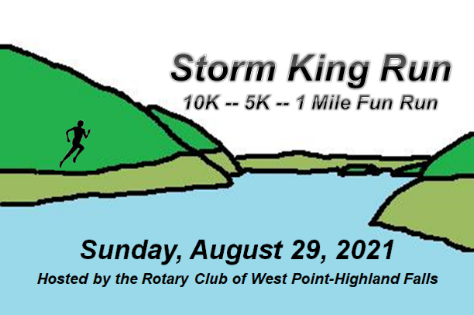

Challenging 10K, 5K, and 1-Mile Kids Fun Run along the historic Hudson River.
Proceeds benefit the Scholarship Fund of the West Point-Highland Falls Rotary Club.

Parking in the US Mint/West Point Ski Slope parking lot.
Info and Register Online Here:
rotary-wphf.org/StormKingRun.html

QR Code:
Start / Finish is near West Point's Washington Gate on NY-218.

Event Schedule:
7:30 a.m. Packet Pick-Up and On-Site Registration opens
9:00 a.m. 1-Mile Kids Fun Run (11 and under)
9:15 a.m. 10K / 5K Start

Awards Ceremonies will follow each race at the respective finish areas.
Awards for top finishers in each age/gender category.

Walkers / Volksmarchers are welcome. Race will be held rain or shine.
Multiple water stations on the race routes.

All paid registrants will be provided a race t-shirt, goodie bag, and food/beverages.

10K/5K Registration Fee: $25 (Race Day: $30)
USMA Cadets / USMAPS CCs: 10K/5K Registration Fee: $15 (Online and Race Day)
1-Mile Kids Fun Run: $10 (Online and Race Day)

10K route: http://www.mapmyrun.com/routes/view/73460968

Race chip timing by Super Race Systems.
DJ at start / finish provided by Party Time Productions.

10K/5K Age Divisions: 18 and under, 19-29, 30-39, 40-49, 50-59, 60-69, 70 and up

Race Director: John Willis (WP-HF Rotary Club)
Email: StormKing10k@gmail.com
Phone: 831-236-6663

2021 Storm King Run
Race Category (circle one): 10K
5K
1-mile Kids Fun Run

T-Shirt Size (circle one): S M L XL XXL

First Name: _______________________________
Last Name: _______________________________
Address: _________________________________
City, State, Zip: ____________________________
Email Address: ____________________________
Phone Number: ___________________________
Birth Date: ________________________________
Gender (circle one): Male Female
USMA Cadet/USMAPS CC?: Yes No
Age on Race Day (Aug 23, 2020): ________

Registration Form
Mail this form with entry fee check payable to:
WP-HF Rotary Foundation
Storm King Run
55 Rose Drive
Highland Falls, NY 10928

Waiver: I know that running/walking in a race is a potentially hazardous activity. I should not enter and run/walk unless I am medically able and properly trained. I agree to abide by any decision of a race official relative to my ability to safely complete the run. I assume all risks associated with running this event including, but not limited to, falls, contact with other participants, the effects of the weather, including high heat and/or humidity, traffic and the conditions of the road, all such risks being known and appreciated by me. Having read this waiver and knowing these facts and in consideration of your accepting my application, I for myself and anyone entitled to act on my behalf, waive and release the race organizers, New York State, the county, towns, and villages in which this event is held, and all sponsors, their representatives and successors from all claims or liabilities of any kind arising out of my participation in this event even thought that liability may arise out of negligence or carelessness on the part of the persons named in this waiver. I grant permission to all of the foregoing to use any photographs, motion pictures, recordings or any other record of this event for any legitimate purpose.
I HAVE READ THIS WAIVER CAREFULLY, UNDERSTAND IT, AND SUBMIT TO ITS CONDITIONS.

Required Signature of Participant: _______________________________________________________

Required Signature of Parent if Participant is under 18: _______________________________________

Date: ________________________________________

